Chair of Governors
Mr Marvin Smith

Clerk of the Governors
To be appointed

Enw / Name | Llywodraethwr | Governor
Marvin Smith | Cadeirydd | Chair
Ceinwen Parry | Is-Gadeirydd | Vice-Chair
Alan Marshall | Cyngor Cymuned | Community Council
Gwenan Roberts | Awdurdod Lleol | Local Authority
Gwenda Smith | Staff | Staff
Catrin Williams | Athro | Teacher
Siân Rogers | Rhiant | Parent
Vici Ladeji | Rhiant | Parent
Heather Williams | Cymunedol | Community
Nia Connah | Pennaeth | Head
 | Clerc | Clerk

Chair of Governors
All pupils returned in September after a difficult year. All pupils and staff settled back quickly and everybody worked hard up to Christmas when unfortunately, school closed early due to Covid numbers rising again. The country was once again put into lockdown in January 2021. During lockdown key worker children attended the school Hub.
The children worked from home until March when we staggered the return for pupils for two weeks before Easter Holidays. After Easter all pupils returned to school under different conditions again. The leavers concert was held outside on the last day and everyone wished Miss Harrison all the best for her wedding when she returned as Mrs Williams in the new term.

We await the final publication of the new curriculum in Wales in 2020. The ambition of the Welsh Government is to make sure that learning and experiences in school better prepare children and young people for life outside of school with things like career paths and the part they play in their community. I believe that this is exactly what Ysgol Terrig has done and will continue to do, giving our children a strong foundation that is a spring board to a career path of their choice, whilst installing citizen values to care and help others. Of course, being fully bilingual will open additional career doors and foster our special cultural heritage.

Strategies and Policy
The Governing Body has approved the School Development Plan. The plan focuses on the year ahead. The School Development Plan is reviewed by the Governing Body at its meetings.
The Governing Body approves all school policies, this includes those policies legally required and those that are recommended.
All policies are available at school, some are on the school website.
Cynllun Datblygu Ysgol
Priority 1 – Wales Curriculum
Prirotiy 2 – Health and Well Being
Gwerthuso
Monitoring the School Development Plan

Priority 1 – To improve the quality of teaching and learning
Due to the pandemic, not all aspects of the priority have been met. As a school we did host some in-house training, with the view to have training by a Mantle of the Expert school. Unfortunately, this has not happened.
As a school we have embraced the teaching style of Mantle of the Expert and it has been effective in meeting the challenges of the new Curriculum for Wales 2022.
TheAction Plan for the future is to have further training for staff delivered as soon as it is safe to do so.

GH has monitored the classes recently and reported back to staff – next steps for all was further training.

Priority 2- To improve the quality of assessment
All staff report every term about the progress of each pupil. This is to ensure that each pupil is making progress and if they are not that these issues can be addressed. All pupils are given targets to ensure progress. All staff meet with the HT to discuss each pupil individually.
For those who are not progressing they are included on a provision map (a provision map is a document for each staff member to track pupils who are given individual help or groups work to assist them to meet targets)
All pupils year 2 upwards had benchmarking tests at the end of September and they will be revisited before the Summer.
Books have been monitored on a regular basis by HT – the latest report was just before half term. Findings were good with minor issues to be addressed.

Action Plan –
- handwriting and less use of photocopies in some classes.

Priority 3 – To strengthen the teaching of phonics, speaking, listening and improving reading in school
HT visited a cross section of pupils in all classes and listened as well as discussed books with the pupils. Findings were that almost all pupils enjoy reading. Most pupils could discuss the books they were reading. Most could recall the story but only around half could predict the story. The younger pupils in Meithrin have onlly recently started reading and were making progress. Many of the Meithrin pupils had completed the first step and were working through the second step of recognising letters and cvc words. Few nursery pupils are reading books with more pupils targeted by the end of the Summer Term.
Tests at the beginning of the year target reading skills. These will be re-visited by the end of the Summer term to see what progress each pupil has made.
All pupils, year 2 – 6 have completed the National Reading Tests. This year no mark was actually given only a narrative on what each individual pupil had achieved.
Reading resources have been bought to ensure all pupils needs are being met – new books in Welsh and a listening station to be shared in the Foundation Phase classes.

Action Plan –
- to ensure that each class follows the morning routine of reading activities
- all pupils are listened to on a regular basis
- reading record is put on seesaw for every class

Other reports that have been written to meet the requirements of the SDP

CH – Shirley Clarke – formative assessment. CH visited each class in turn to monitor the steps we had put in place last year and which are on-going. This is part of well-being of a child within the classroom and how pupils assess their own learning.

ED – the use of Welsh in the classroom, this is also an initiative led by County and training was given on teams. ED monitored the use of the initiative in each class and reported back to the County Officer.
ED has also addressed targets set in the equality policy and discussed some of the issues with an Estyn inspector

ALN
The new ALN transformation programme also focuses on skills development for the education workforce, to deliver effective support to learners with ALN in the classroom, as well as easier access to specialist support, information and advice. Why it’s changing We are determined to deliver a fully inclusive education system for learners in Wales.
NC has led the school on various training programmes and the school is moving forward in meeting the criteria of the new ALN Code.
NC met with a County Officer and a report written on our progress

Finance
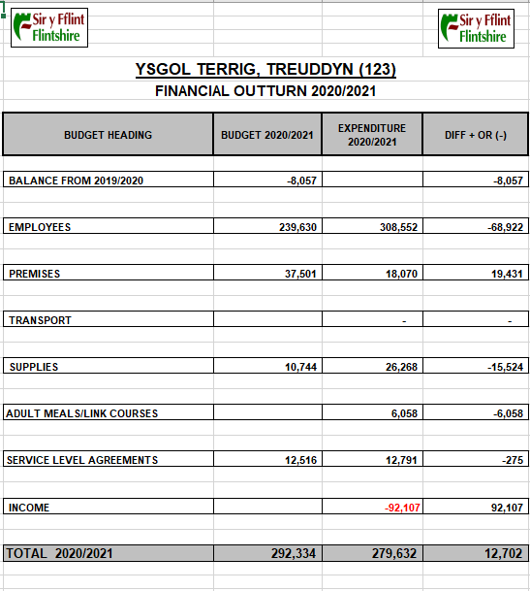

Attendance
Attendance was not reported due to Covid
National Curriculum
Foundation Phase
Learning for 3 to 7 years is based on the Welsh Government Foundation Phase Curriculum. This curriculum is based on educational research on an understanding of how children learn.
In every class in the Foundation Phase there is 1 adult to every 10 children. This enables staff to care for these children and the staff can observe their learning and plan the next steps.
The Curriculum is planned to give the children the best opportunities and develop their creativity. Key skills in literacy, numeracy and Digital learning are taught in a structured way in all areas of learning.

Key Stage 2
Key Stage 2 pupils follow the National Curriculum. It is a skills based curriculum and topics are chosen to interest the children as well as developing subject knowledge. Literacy, Numeracy and Digital Competency skills are taught cross curricular.

Additional Learning Needs
The pupils who have been identified can receive support in various ways; within the class, in small groups or individually.
The ALNCo works along staff to identify pupils who require extra support and liaises with parents and outside agencies to ensure that the pupils meet their targets.
Classroom assistants play an important role in supporting pupils within the classroom, in small groups and individually.

Communication and Partnership with parents
The calendar on our website is updated regularly and there is information about individual classes. Letters are also uploaded and are also sent home. School have a twitter account Instagram and Facebook. These are updated with photos and information.
Parent evenings are held in the Autumn Term and Spring Term and all parents are invited in.
Parents have the opportunity to attend Christmas concerts and all pupils take part. All parents are invited to our Thanksgiving service and St David’s Day concert. Parents are also invited to the end of year leaving concert and year 6 parents are invited to have lunch with their children.

Toilets
There is sufficient number of toilets for pupils on roll. There are also 2 disabled toilets. Toilets are cleaned daily and are checked by staff throughout the day. Toilet facilities are monitored by the County Officer on a regular basis. They are kept well supplied. Any defects are reported to the head.

Health and Fitness
All pupils move for 12 minutes per day as part of the mile a day initiative. Foundation Phase pupils have planted vegetables in the garden. They spend time in the Forest School to learn about the outside.
The school plan and deliver how to stay safe on the internet.
The sexual and relationship Education is part of the school curriculum plan.

Welsh Language
Welsh is the school’s language. The school received a Gold award for its Welsh Charter work. As a school we have raised awareness in the pupil’s heritage and the pupils are conversing through the medium of Welsh naturally. Miss Davies has been working on Welsh Charter targets but not all targets were achieved due to Covid restrictions.

Visits
Due to Covid restrictions no visits were made during the year

