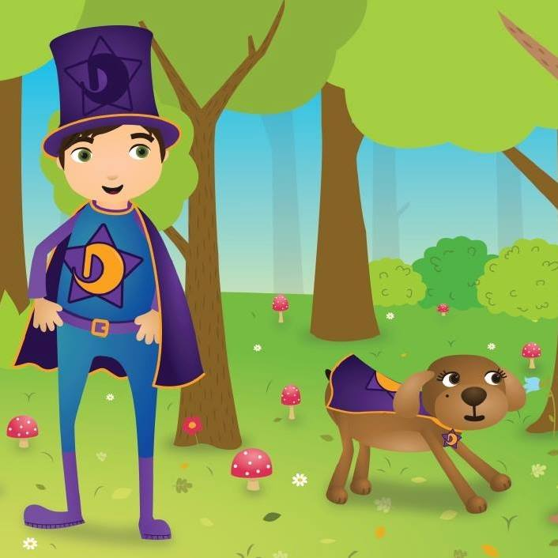
2023/24

Cylch Meithrin Terrig (Playgroup)
Day Care
7.45 – 5.45 Weekdays
Ffordd y Llan
Treuddyn
Mold
01352 770235

zdgfgsfgfdssds
[Type the phone number]
[Type the fax number]

CYLCH MEITHRIN TERRIG

YsgolTerrig
Ffordd y Llan
Treuddyn
Mold
Flintshire
CH7 4LN

Cylch phone number - 07842 164 498

YsgolTerrig phone number-01352 770235

Website: www.ysgolterrig.org.uk
Rhieni/Parents – Cylch Meithrin Terrig

Charity number - 1055989

STAFF

Manager – Sonia Suarez Griffiths
Leader – Lauren Hughes
Playgroup assistants –Emilia Navarro-Howe, Olivia Northall, Kerrie Ford, Ella Vaughan, Ellie Williams
MUDIAD MEITHRIN
Development officer - Gaenor Richards
COMMITTEE
Registered person – Nia Connah
Chairperson – Nia Connah
Vice-Chair – Mel Cunningham
Treasurer –Gwenda Smith
Secretary – Helen Morgan

WELCOME

Welcome to Cylch MeithrinTerrig, a Welsh medium playgroup for children aged 2 years to 4 years and provide after school provision up to Year 2. We welcome children from Welsh, bilingual and non-Welsh speaking families.

The Cylch is managed by a voluntary committee and is a member of Mudiad Meithrin (MM), the main provider of Welsh-medium early years care and education in the voluntary sector.

The Cylch is a registered charity non-profit organisation. We cover the cost of salaries, day to day running costs and equipment, from fees, fundraising and grants.

We are registered with CIW (Care Inspectorate Wales) where we have an annual inspection.

AIMS AND PRINCIPLES OF THE CYLCH
The main aim of the Cylch is to provide children with an opportunity to benefit from quality early years care and experiences through the medium of Welsh.

We aim to provide a happy, secure family atmosphere, where your child can develop as an individual. As play is integral to every aspect of children’s development, the experiences and activities offered in our Cylch are based on learning through play.

WE BELIEVE THAT EVERY CHILD HAS THE RIGHT TO:

-Receive care, love and respect.
-Receive appropriate attention and support in order to meet his individual needs.
-Benefit from every opportunity to play.
-Guidance which will enable him to become a full member of society.
-Be stimulated to enable him to develop to his full potential.
- Benefit from early years experiences through the medium of Welsh.
-Be treated as an equal, irrespective of race, colour, religion, nationality or social background.
-Expect every adult who is responsible for him to defend him from all harm.
-Develop his own identity and his sense of belonging to his local community.

STAFF
The Cylch is staffed by a playgroup leader and playgroup assistants who are qualified and experienced in early years care and education, and undertake continuous professional development in these areas. All staff members are DBS checked (Disclosure and Barring Service- previously CRB), and are qualified in paediatric first aid, child protection and food hygiene.

FOUNDATION PHASE

The foundation phase statutory curriculum set by the Welsh government encourages children to be creative, imaginative and makes learning more enjoyable and more effective. The Foundation phase has 7 areas of learning -

*Personal and Social Development, well-being and Cultural diversity
*Language, literacy and communication skills
*Mathematical development
*Welsh language development
*Knowledge and understanding of the world
*Physical development
*Creative development

We aim to provide a stimulating atmosphere which allows children to develop in the areas set out by the foundation phase. We provide opportunities for play with sand, water, play dough, paint and craft, dressing up and creative role play, outdoor play, music and movement, and much more.

The emphasis is always on enjoyment and play, and the children learn to socialise by playing together. The routine set for each session is good preparation for the more formal structure of primary school education, we hope that being in contact with the staff and pupils of Ysgol Terrig will ease them into school life when the time comes for them to move up to nursery class.

LANGUAGE
We believe that acquiring the Welsh language is of benefit to children. As a CylchMeithrin we believe strongly in the immersion method and feel it is the best start for your children in their future as a Welsh speaker, therefore during our sessions staff will predominantly speak to the children in Welsh, but naturally English will be used to explain certain points when needed.

YOUR CHILD’S PROGRESS
The playgroup leader records each child’s individual development in the “This is me!” booklet. Positive comments about your child’s development during the year will be documented regularly.
A copy of this booklet will be shared with parents once a year, and a copy is given to the school your child will attend, so they can see your child’s progress.

ATTENDANCE AND PAYMENTS
The days your child will be attending the Cylch need to be specified so that we can arrange staffing levels, a contract will need to be signed to allocate your child that session. Your child can attend extra non-contracted days if there is space available.

Fees are payable half termly, weekly or daily IN ADVANCE. Unfortunately, due to the running of the Cylch relying on fees we are unable to allow your child to attend if payment has not been received in advance.
If a child is absent, payments will not be refunded or carried over.

If a child is likely to be off long term, 1st week will be full payment, then arrangements should be discussed with staff/committee.
If a child is absent for more than 3 weeks without explanation, we reserve the right to allocate the place to another child.
Bills are issued at the end of each month via email.
We are able to accept BACS payments. Bank details are-
Account number - 10243232
Sort code – 541010

We accept childcare vouchers
DAYS AND TIMES
Monday 7.45am-5.45pm
Tuesday 7.45am-5.45pm
Wednesday 7.45am-5.45pm
Thursday 7.45am-5.45pm
Friday 7.45am-5.45pm

PRICES
7:45 - 5:45 - £35.00
7:45 - 13:00 - £17.00
7:45 - 11:30 - £12.00
7:45 - 9.00 - £5.00
9:00 -15:00 - £18.00
9:00 - 11:30 - £8:00
11:30 - 17:45 - £22.50
11:30 - 15:00 - £6.00
15:00 - 17:45 - £12.50
3:00 - 5:00 - £10.00
3:15 - 4:15 - £5.00
4:15 - 4:45 - £2.50
5:00 - 5:45 - £2.50
Full Day Package
Includes Breakfast, Lunch and Tea
£35

REGISTRATION
Before starting your child at the Cylch, you will need to complete a registration form, and other forms related to the policies we adhere to. This ensures we know everything we need to know about your child while they are attending the Cylch. Please inform us of any changes to your child’s details.

EARLY ENTITLEMENT
We participate in the Welsh government Early Entitlement scheme and are therefore able to provide free early years education sessions the term following your child’s 3rd birthday. For more information speak to nursery staff.

30 HOUR CHILDCARE OFFER
We are registered to provide the Welsh Government funded offer we are open all year, meaning you can take full advantage of this offer. For eligibility check https://www.flintshire.gov.uk/en/Resident/Schools/Eligibility-Checker.aspx

.

PARENTAL CONTRIBUTION
The Cylch is run by a committee who are parents. As parents you become members of the Cylch and can become committee members. You can support the Cylch in many ways such as fundraising and helping out when we are short staffed. The committee meets once a term and all parents are welcome. An annual AGM is held where all parents are asked to attend.

SETTING
The Cylch sessions are held at YsgolTerrig, where children are able to use the school hall, toilets, playground and field, however the Cylch is run independently of YsgolTerrig. There is an excellent working partnership between the staff of the Cylch and YsgolTerrig which provides the children with a good foundation for school life.

FOOD AND DRINK
A healthy Breakfast will be provided for children arriving before 8.30am. Children can bring a packed lunch, or school dinners can be ordered (School dinners are £2.50). Tea can be ordered if required at £2.50 a day. A healthy snack and drink will be provided mid-morning and mid-afternoon. Please do not send food, sweets and drinks with your child so we can adhere to our healthy eating/drinking policy.
Full day package at £35.00 includes breakfast, snacks, school dinner and tea.

POLICIES
The Cylch have the following policies in place. Here is a brief description of each one, if you wish to read the full policy, or for more information, speak to the nursery staff that can help.

SUN PROTECTION - Please provide children with suitable clothes and hats for the hot weather. High factor sun cream should be supplied and labeled with your child‘s name. Please fill in form EH to consent to staff assisting children to apply sun cream.

ASTHMA - Please provide information to staff about your child’s asthma symptoms, triggers and medication requirements. Provide medication that is in date and clearly labeled with your child’s name. Update staff of any changes to your child’s condition.

ACCIDENTS- Any accidents will be recorded in the accident book, parents will be notified and the book should be signed by the parent.

HEALTHY EATING AND KEEPING FIT- We continually encourage healthy eating at the Cylch, providing a healthy snack and milk or water mid morning and mid afternoon. Drinking water will be available throughout the day. Please advise us of any intolerance or allergies your child may have, so we can arrange alternative snacks/drinks.
We hold physical activities indoors and outdoors every day so that the children have the opportunity to keep fit.

KEEPING CHILDREN WITHIN THE PREMISES - We ensure that the children stay within the Cylch’s premises and its environment and that they cannot wander off.

COMPLIMENTS AND COMPLAINTS - We aim to provide a service of the highest standard, and we welcome the opinions of parents/guardians about the service we provide. If you are dissatisfied with any aspect of the Cylch’sservice the Cylch have procedures in place to follow. The first step is to contact the Cylch leader or registered person to voice a complaint verbally.

WHISTLE BLOWING - The Cylch’s policy is to conduct its business with honesty and integrity and all staff and volunteers are encourages to report suspected wrongdoing. Whistle blowing is the reporting of suspected wrongdoing or dangers in relation to the Cylch’s activities. This includes bribery, fraud or other criminal activity, miscarriages of justice, health and safety risks, damage to the environment and any breach of legal or professional obligations.

EQUALITY AND DIVERSITY - It is the Cylch’s aim to provide an inclusive environment that promotes contribution and participation from everyone associated with the Cylch. The Cylch will ensure that every sector of the community, especially those from disadvantaged backgrounds, and without considering the language spoken, are aware that the Cylch’s activities are available to them.

CONFIDENTIALITY - The Cylch aims to ensure that all the information about the staff, the children and families is kept securely and in confidence, and that no information is shared or revealed to persons/agencies not authorised to receive the information.

INCLUSION - The Cylch is committed to providing appropriate support for every child in the Cylch who has additional educational needs. The Cylch will work in partnership with the local referral scheme and other relevant agencies to ensure help and support for the child and family.

ADMISSIONS- Every child within the appropriate age range is welcome to attend the Cylch, regardless of his/her needs, colour, race, language, religion, social class or family situation.

SAFEGUARDING - The Cylch promotes an atmosphere and ethos which enables children, staff, and volunteers to express any concerns they have openly. The child protection policy and procedures adhere to “Working together” under the 2004 Children’s Act.

DATA PROTECTION - The Cylch aims to ensure that personal information regarding the staff, students, volunteers, parents and children are kept in accordance with the statutory requirements of the General Data Protection Regulation.

LEAVING AND COLLECTING CHILDREN - The Cylch’s aim is to implement procedures which will ensure that every child is left in the Cylch and collected in complete safety. Form CP1 must be filled in with the details of each individual who has the right to collect your child.

PROMOTING POSITIVE BEHAVIOUR- The Cylch aims to provide an environment based upon clear, fair and consistent guidelines which promote a child’s understanding of acceptable behaviour. Every child will be respected and the children are encouraged to respect other children, adults, equipment and the Cylch premises. The staff will take positive actions to modify unacceptable behaviour, and acknowledge and praise good behaviour at all times. In a case where a child’s behaviour causes concern, the Cylch leader will discuss the situation positively with the parent/guardian and a plan of action will be developed.

THE WELSH LANGUAGE - The aim of the Cylch is to offer every pre-school child the opportunity to have early year’s experiences through the medium of the Welsh language. The Cylch believes that acquiring the Welsh language benefits children. The Cylch will ensure that all the activities for the children are conducted through the medium of Welsh.

HEALTH, SAFETY AND WELFARE - The Cylch will do everything it can to ensure the health, safety and welfare of the staff, the children in its care, students, volunteers and visitors. The Cylch will conform to the requirements of the current health and safety legislation.

The Cylch will -
-Ensure that the environment inside and outside the is safe
-Undertake a regular risk assessment of the building and its environment
-Ensure that there is an accident book, and ensure the staff record every accident and incident.
-Ensure that staff have first aid qualifications
-Ensure that there is a telephone or mobile phone available
-Ensure that all members of staff attend health and safety courses.

FIRE SAFETY - The Cylch will meet fire safety standards in accordance with the Regulatory Reform Fire Safety Order 2005.

NAPPY CHANGING - If a child attends the Cylch in nappies, we will change the child’s nappy at regular intervals, and at any other times when the child is wet or soiled. Please provide nappies, wipes and nappy bags. Pull up nappies would be preferred if your child is toilet training for convenience.

CLOTHING - Please provide appropriate clothing for the weather, bearing in mind that they will be playing outside (unless extreme weather). Please provide a change of clothing incase of accidents.

CHILDRENS SAFETY ON SCHOOL TRIPS/VISITS - It is the responsibility of the staff to ensure the children’s safety on visits outside the Cylch. The Cylch will ask for written consent from parents’ beforehand (CMY form) and undertake a risk assessment of any visits outside the Cylch.

MEDICINES - Medication can be given to a child if it is medically prescribed (i.e. antibiotics), or in specific circumstances (i.e. pain relief for teething). The medication must be provided, clearly labeled with the child’s name. A consent form M1 must be completed in order for the staff to administer the medication.

ILLNESS - If you child becomes ill during a Cylch session, the staff will inform you immediately on the contact details you have provided. If your child is suffering from diarrhea and/or sickness, we request your child does not attend the Cylch for 48hrs after the symptoms have stopped.

FOOD HYGIENE - Staff will receive regular food hygiene courses and adhere to the guidelines.

STAFFING - The Cylch adheres to national guidelines in relation to the ratio of staff to children. 1 staff to 4 children (aged 2-3), and 1 staff to 8 children (aged 3-4). There will always be 2 members of staff on duty at all times regardless of number of children present

TAKING PHOTOGRAPHS AND NETWORKING - We aim to protect the Cylch’s children from any harm deriving from the misuse of networking sites. The Cylch places as paramount the protection and safeguarding the children in its care, and this includes avoiding any misuse of images. The policy regarding taking photographs offers guidelines to staff and volunteers, in order to establish a balance between the importance of protecting the children in their care from the misuse of images, and the desire to raise awareness and to give publicity from the Cylch’s work and activities.

The Cylch will -
-Ensure that written consent of parents/guardians in order that photographs of their child can be taken for Cylch use. This can include use for scrapbooks, social media and wall exhibition in the Cylch and local news articles.
-The children in the photographs will not be named.

CONCLUSION

We hope this information booklet has been useful, and covers a general overview of the Cylch. If you require any other information, please do not hesitate to speak to a member of staff.

We are confident that your child will be happy at the Cylch, and that learning the Welsh language will be of great benefit to the future of your child

